**TASK REPORT**

**ALGORITHMS AND DATA STRUCTURE**

**WEEK 5**

**Created by:**

**Onic Agustino**

**L200234275**

**X**

**INFORMATICS ENGINEERING**

**FACULTY OF COMMUNICATION AND INFORMATICS**

**UNIVERSITAS MUHAMMADIYAH SURAKARTA**

**2024/2025**

**TASK**

1. **Try the previous source code to make a linkedlist structure and use traverse, insert at the beginning, insert at last, insert at the middle and remove nodes method.**

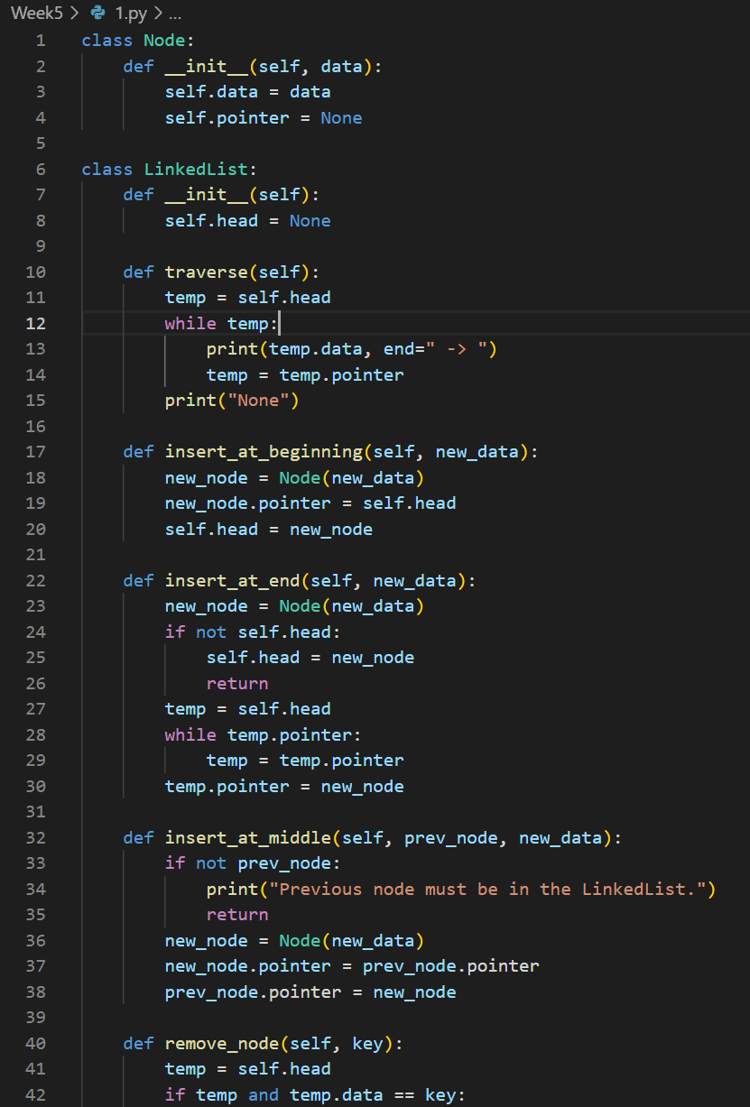

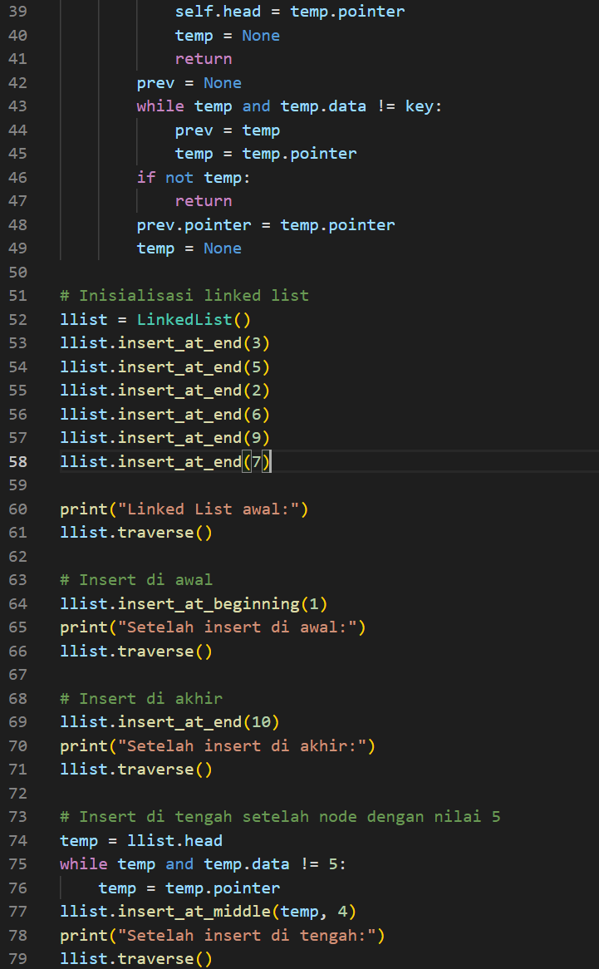

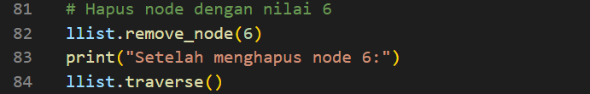

Picture 1.1 the code.

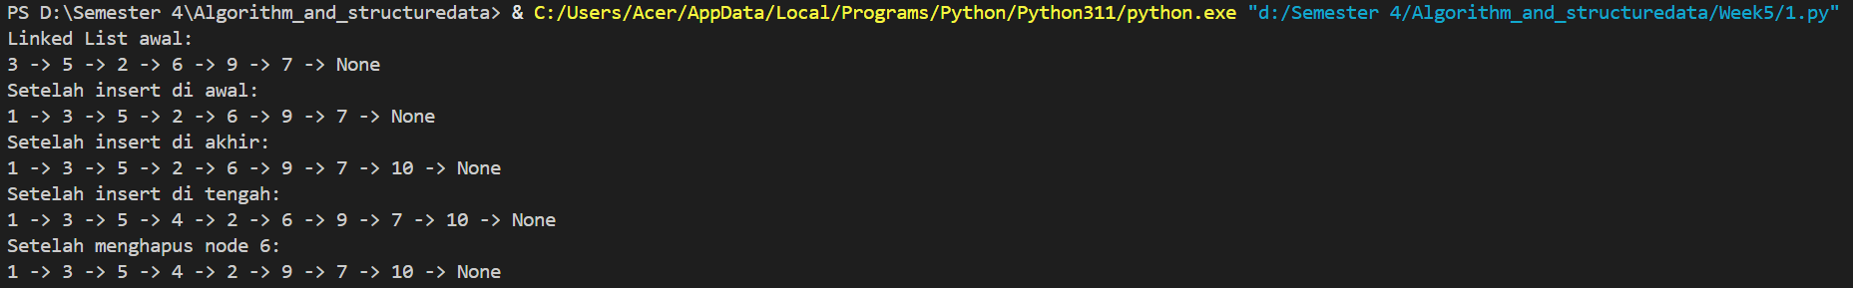

Picture 1.2 the output.

1. **Build a single linked list which contains 6 nodes, where each node has an integer value. The value of the integers are 3,5,2,6,9,7. Then, sum all of these integers by traversing the linked list from the head node until the tail node.**

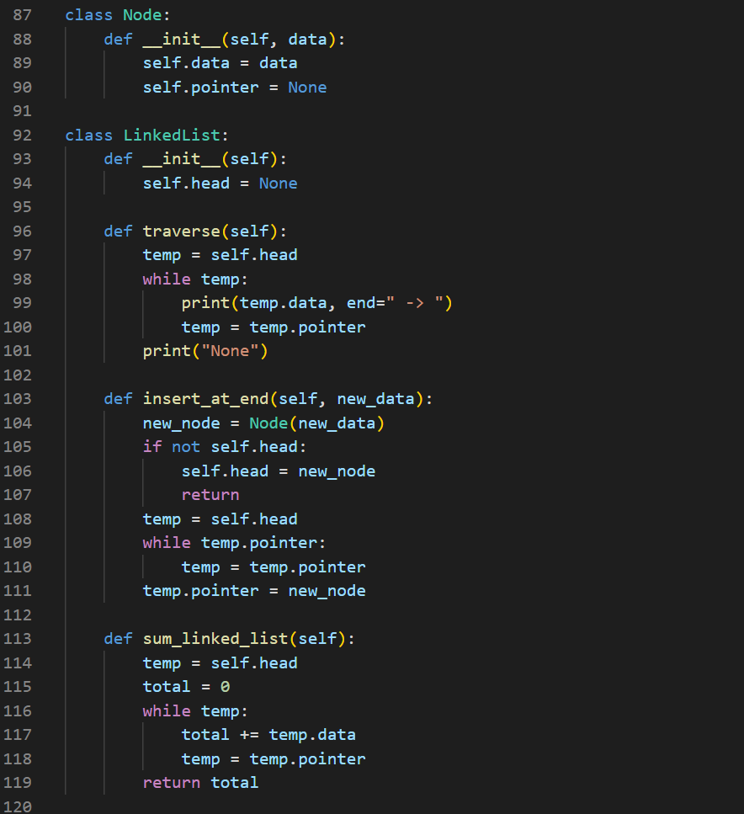

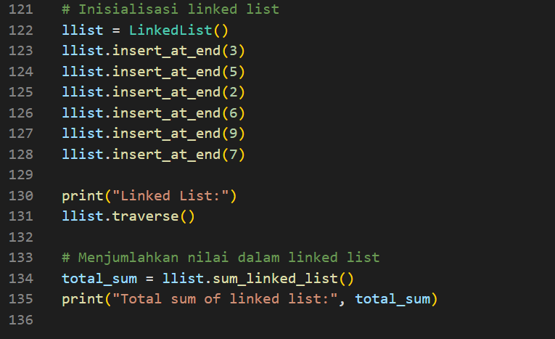

Picture 2.1 the code.



Picture 2.2 the output.